Name: Divyansh Dubey

Roll no: 231070001

Course: DAA

Program: B. Tech Computer Engineering 2nd year

Batch: A

**Assignment- 3**

**Aim:** Which code editor (IDE) are you using for your programs?  
Install Visual Studio Code and use it for your programs.  
View Introductory Videos   
1. Getting Started  
2. Code Editing  
3. Productivity Tips  
4. Extensions  
  
  
Write an algorithm to find gross and net salary of employees.  
ABC co. ltd. has 2000 employees.   
your task is to calculate each employees salary and find employee with minimum salary and maximum salary.  
  
Do the above task using  divide and conquer technique.   
Find the improvement in the complexity using divide and conquer method.

Algorithm:

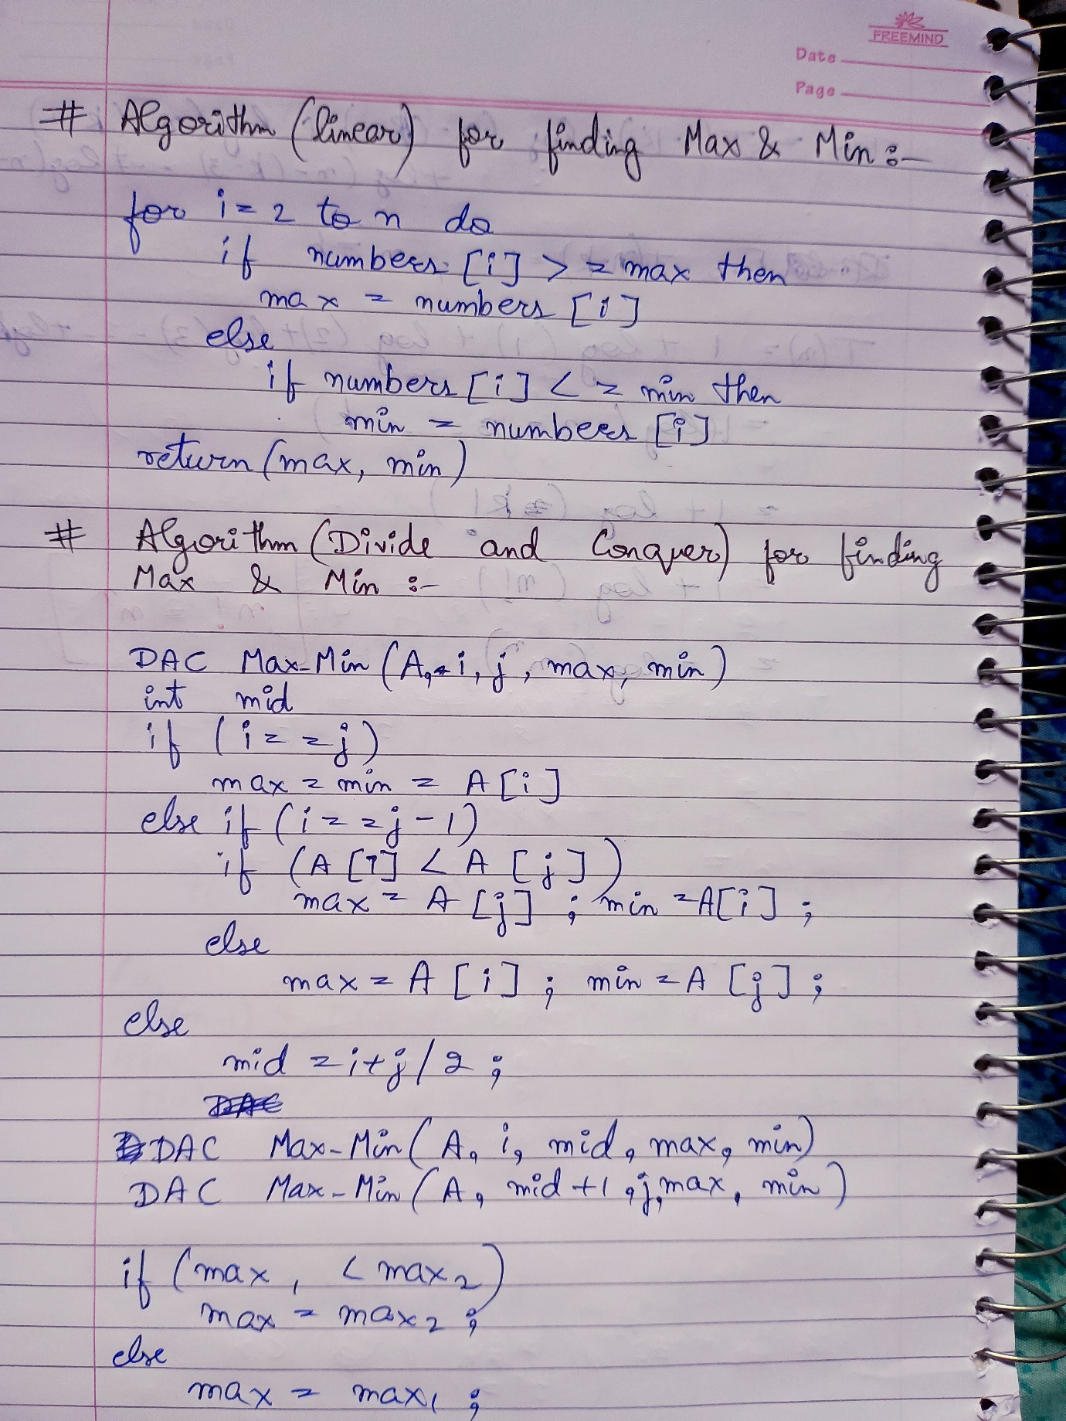

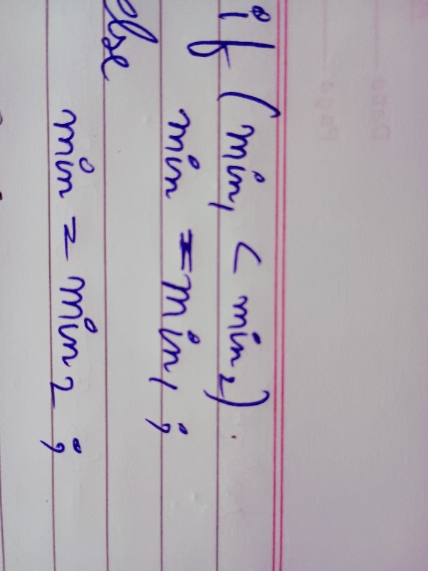

TIME COMPLEXITY:

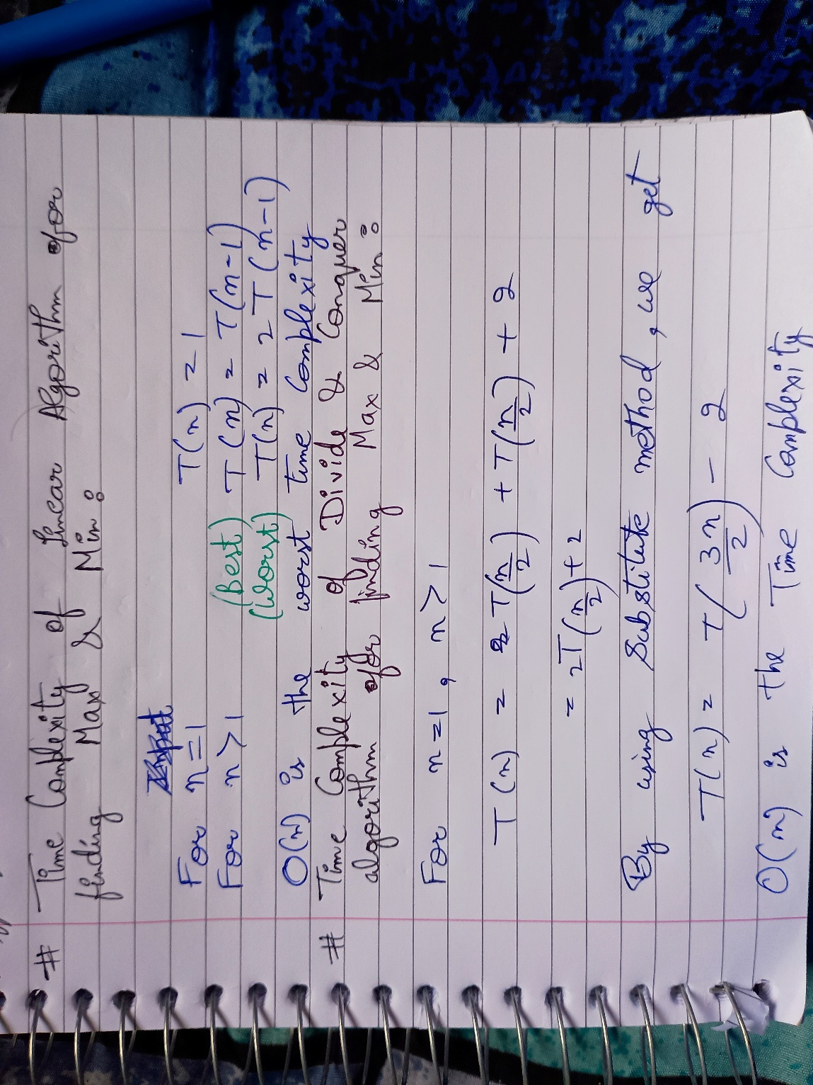

TEST CASES:

Positive test cases:

1. Input: Having more than 2 employees.

Enter the number of employees for whom you want to calculate the salary: 3

Salary details of employee 1 :-

Enter the base salary of employee 1 :

1000

Enter the allowances of employee 1 : 100

Enter the Provident fund of employee 1 : 200

Salary details of employee 2 :-

Enter the base salary of employee 2 : 3000

Enter the allowances of employee 2 : 300

Enter the Provident fund of employee 2 : 100

Salary details of employee 3 :-

Enter the base salary of employee 3 : 2000

Enter the allowances of employee 3 : 200

Enter the Provident fund of employee 3 : 100

Expected Output:

Gross salary of employee 1 is: 1100

Net salary of employee 1 is: 800

Gross salary of employee 2 is: 3300

Net salary of employee 2 is: 2900

Gross salary of employee 3 is: 2200

Net salary of employee 3 is: 1900

Maximum Gross salary out of all employees is : 3300

Minimum Gross salary out of all employees is : 1100

Employee 2 has the maximum salary

Employee 1 has the minimum salary

1. Input: Having only one employee.

Enter the number of employees for whom you want to calculate the salary: 1

Salary details of employee 1 :-

Enter the base salary of employee 1 : 2000

Enter the allowances of employee 1 : 200

Enter the Provident fund of employee 1 : 500

Expected Output:

Gross salary of employee 1 is: 2200

Net salary of employee 1 is: 1500

Maximum Gross salary out of all employees is : 2200

Minimum Gross salary out of all employees is : 2200

Employee 1 has the maximum salary

Employee 1 has the minimum salary

1. Input: Having exactly two employees.

Enter the number of employees for whom you want to calculate the salary: 2

Salary details of employee 1 :-

Enter the base salary of employee 1 : 1000

Enter the allowances of employee 1 : 122

Enter the Provident fund of employee 1 : 11

Salary details of employee 2 :-

Enter the base salary of employee 2 : 2000

Enter the allowances of employee 2 : 200

Enter the Provident fund of employee 2 : 500

Expected output:

Gross salary of employee 1 is: 1122

Net salary of employee 1 is: 989

Gross salary of employee 2 is: 2200

Net salary of employee 2 is: 1500

Maximum Gross salary out of all employees is : 2200

Minimum Gross salary out of all employees is : 1122

Employee 2 has the maximum salary

Employee 1 has the minimum salary

Negative Test Cases:

1. Input: Having more than 2000 employees.

Enter the number of employees for whom you want to calculate the salary: 2001

Expected Output:

Enter valid input

1. Input: Having equal salary of each employee.

Enter the number of employees for whom you want to calculate the salary: 2

Salary details of employee 1 :-

Enter the base salary of employee 1 : 3000

Enter the allowances of employee 1 : 0

Enter the Provident fund of employee 1 : 0 Salary details of employee 2 :-

Enter the base salary of employee 2 : 3000

Enter the allowances of employee 2 : 0

Enter the Provident fund of employee 2 : 0

Expected Output:

Gross salary of employee 1 is: 3000

Net salary of employee 1 is: 3000

Gross salary of employee 2 is: 3000

Net salary of employee 2 is: 3000

Maximum Gross salary out of all employees is : 3000

Minimum Gross salary out of all employees is : 3000

Employee 1 has the maximum salary

Employee 1 has the minimum salary

1. Input: Having no Perks, Allowances and PF.

Enter the number of employees for whom you want to calculate the salary: 3

Salary details of employee 1 :-

Enter the base salary of employee 1 : 10000

Enter the allowances of employee 1 : 0

Enter the Provident fund of employee 1 : 0 Salary details of employee 2 :-

Enter the base salary of employee 2 : 2000

Enter the allowances of employee 2 : 0

Enter the Provident fund of employee 2 : 0 Salary details of employee 3 :-

Enter the base salary of employee 3 : 40000

Enter the allowances of employee 3 : 0

Enter the Provident fund of employee 3 : 0

Expected Output:

Gross salary of employee 1 is: 10000

Net salary of employee 1 is: 10000 Gross salary of employee 2 is: 2000

Net salary of employee 2 is: 2000 Gross salary of employee 3 is: 40000

Net salary of employee 3 is: 40000

Maximum Gross salary out of all employees is : 40000

Minimum Gross salary out of all employees is : 2000

Employee 3 has the maximum salary

Employee 2 has the minimum salary

PROGRAM:

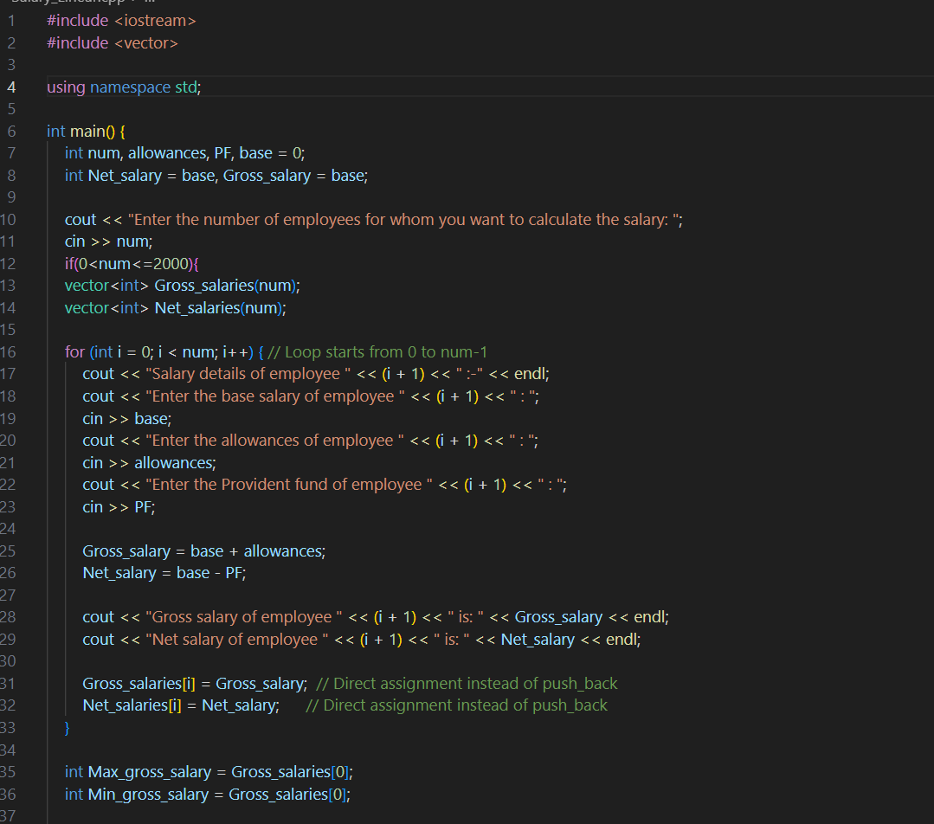

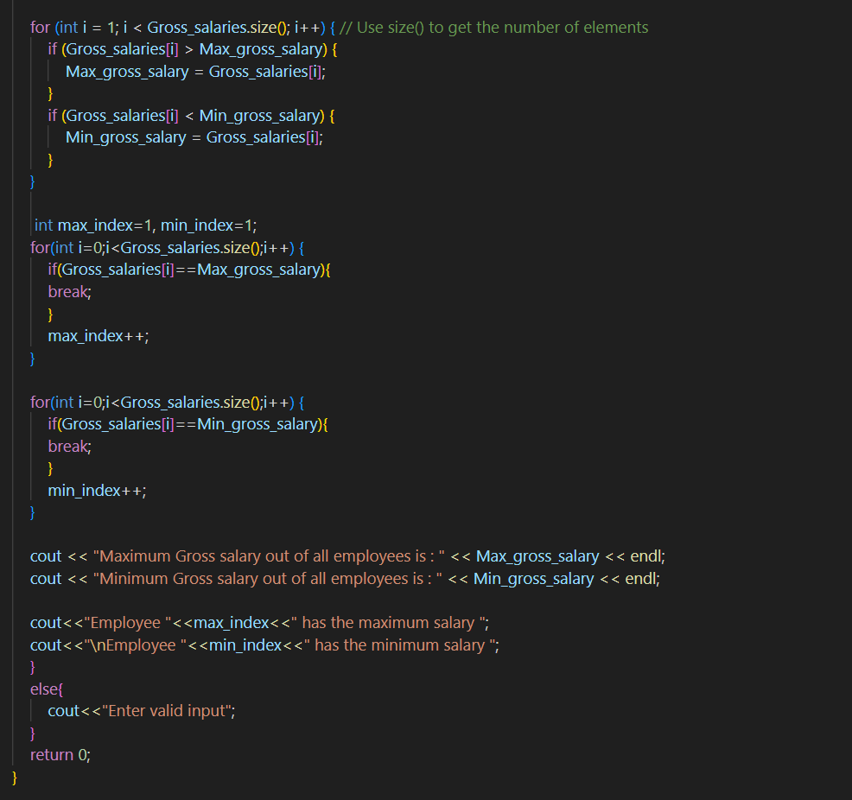

TESTING PROGRAM AND OUTPUT OF TEST CASES:

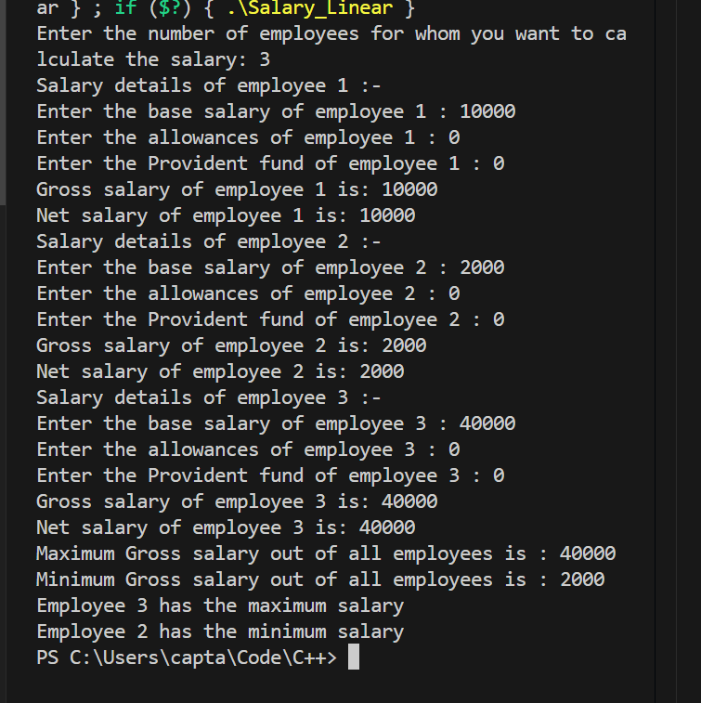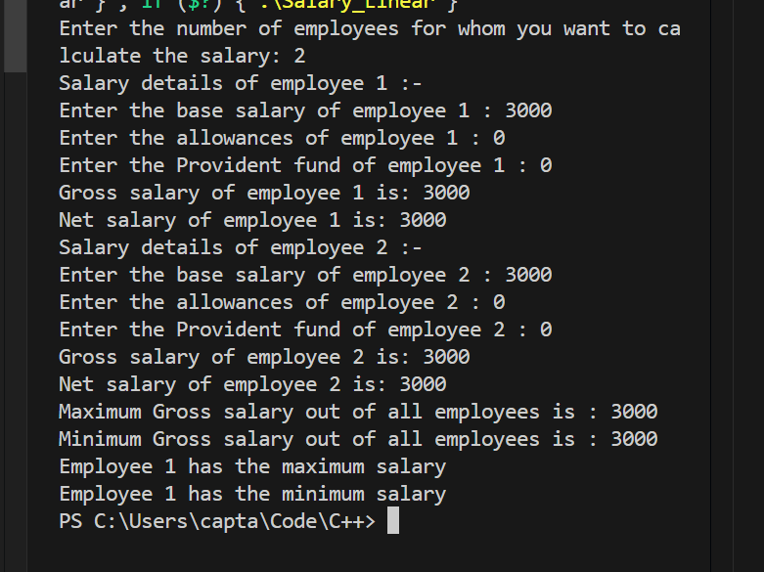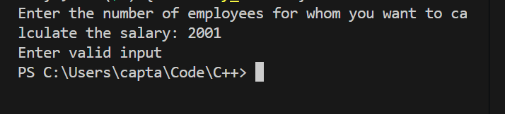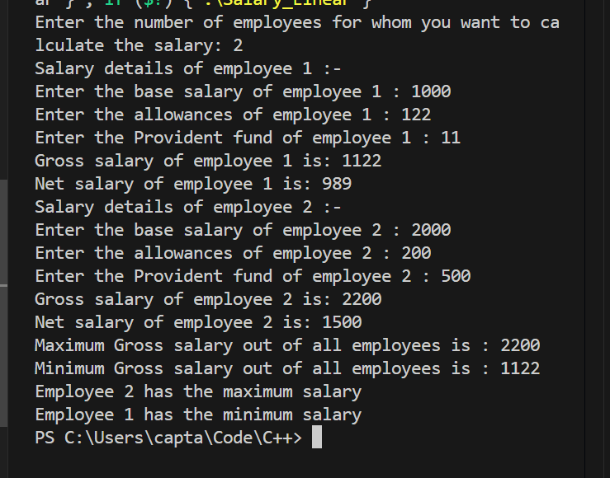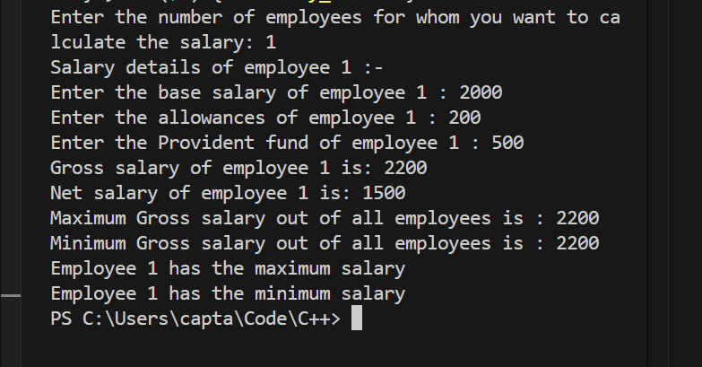

Conclusion:

Currently all these Programs are being run on Visual studio Code editor. It is a very handy and free to install IDE and on the other hand not easy to use at first sight. It allows Programmers to code multiple languages by having different environments and provides various extensions to use. To find the maximum and minimum out of given set of elements can be done by both linear and Divide and conquer technique very easily. Linear approach have the best time complexity of T(n-1) and worst time complexity of 2T(n-1). Whereas Divide and Conquer takes less time to complete the search by taking T(3n/2)-1 time Complexity which is better than linear approach in worst case but not good in best case. Using a good coding style is very important for the viewer for reviewing a program written by a programmer.